**Assignment 1: Flatting App**

**Enyang Zhang ezh15 72004622**

**Jack Greenhill jcg63 31633497**

**Hui Zhuo hzh67 35313654**

**Bryan Lim bli75 39351653**

Date: 18/09/2019

**Abstract**

Assignment 1 tasks us with the design of a flatmate application. A brief was provided from FlatMate Ltd.’s CEO and through that we have made conscious decisions regarding the design and use-flow of the application. This application will be used for the managing and coordination of flat activities, with the goal of making the flatting experience more pleasant.

An important part of designing an application is the preliminary / sketch stage, where many ideas are shared and deliberated on. Through this process, a more focused idea can be achieved as multiple designs for certain pages can show the positives and weaknesses of each design.

In this report, the rationale and design behind every page is shown to demonstrate the best design concepts for the requirement of FlatMate Ltd.

**Introduction**

FlatMate Ltd., a start-up company is looking to develop tools that remain a foundation in the flatting. The experience in itself can be very stressful and troublesome, however through this application they want to eliminate all stress and issues to provide a more civilised experience for all parties involved.

Due to the varying lifestyles of the persons involved in flatting, an important consideration has to be made in regards to the tools that the application provides, as well as the ease of use for the application. Important information must be provided in a clear and concise manner to reduce any misunderstanding that may occur. All of these things will be taken into consideration when solidifying the design of the application.

**User and Task Identification**

As per the brief, the target audience will be directed at students, workers and overseas workers, as these are the most common flatters. A key factor that is shared across these lifestyles are that they often have to work hard and as a result may not have as much time or energy to deal with flat details. This is something that people who live with their family do not have to worry about as their families would have it sorted.

Communication between flatmates is imperative as flatmates may not necessarily know each other even though they live with each other. This can lead to conflicts between flatmates like the cleanliness of house, yellow/red/green bins, gardening, parties and more. It is important to establish some sort of communication so that quarrels can be squashed as early as possible.

Therefore, the app should provide a set of utilities to coordinate those problems. The main categories of tasks that application should have as following:

1. Messaging
2. Daily chores check (rubbish, cleaning, cooking) and assignment of chores
3. Calendar dates for activities (parties, events)
4. Swap duty with somebody
5. Create or edit duty and evets
6. Leave message for other’s events
7. Give somebody suggestion anonymously
8. Personal information
9. Contact with landlord
10. Bill estimation
11. Flatting tips to help newer flat-people
12. Report issues

Below we will discuss in-depth our reasons for these functions.

1) Messaging

Messaging is one of the most important features of this application. Ease of communication can aid flat-relations in every way, especially during the beginning stages where flatmates may not be as comfortable with each other. Another situation where messaging proves important is if a flatmate is running late for dinner, that person can message the flat and tell them to go ahead with dinner.

We designate this as one of the most frequent and important features.

2) Daily chores / assignment of chores

The goal of this feature is to make doing chores as easy as possible. Everyone knows how annoying chores can be so a feature like this can help ease the load of chores and make sure every member is doing their part in the flat. We can provide basic chores that are most common (dishes, rubbish, vacuum) but will also have the ability to create/edit your own chores so that it can be personalised for each flat.

Situations that may occur without this feature is if, someone forgot that it’s their night to cook dinner, the other flat members may be sitting there waiting. However, with the use of the app, we can send a notification to the person with the job of cooking in advance, to remind them that it is their turn to cook today. The application will also include the ability to re-assign chores as some days, people may not able to fulfil their responsibilities and may need a cover.

This task would be frequently used by users and it is very important for users as it directly avoid conflicts between flatmates. Therefore, it is on second priority.

3) Calendar dates for activities (parties, events)

A straight forward feature with the purpose of making it clear to every member in the flat what events are happening in the flat. There are some flats that are event flats and there are some that are quiet, regardless, having a feature where all members can see things that are happening in the flat is important for transparency. Having events known in advance can help other flatmates not involved to plan around the occasion.

This feature is also both of average frequency and importance.

4) Swap duty with somebody

Swap with somebody about duty. As users may not always can do their duty for flat every single time. Scenario is they may want to swap with somebody, when they occupied by their works.

This is important as people may want to easily swap with somebody without do too much effort, swap function will make it easier to do it. Reason that it is forth import because sometime users may busy with jobs, and skip their duty without telling others if it is not easy to swap with somebody. This could lead to confliction.

5) Create or edit duty and evets

This would happen when users meet their flatmates first time, they may what to decide the duty for flat then they set up the duty schedule with app’s help and most likely they will follow the app’s reminder not so often edit it or add a new one.

Therefore, it would not be used so often but must have in order to set up the whole system of the schedule. Important but would not be used so often, fifth priority.

6) Leave message for other’s events

This would happen when flatmates pop up an event, some of the flatmates may not agree with the event as it may disturb them, therefore they may want to ask not to hold the events or give some suggestion by tap holder’s event and submit the message.

This is important design to coordinate events between flatmates, and it may be used as often as create or edit duty and event. High priority as it helps flatmates deal with inconvenient of events and make it easy to be achieved.

7) Give somebody suggestion anonymously

There may be some flatmates having party or keep talking during the night, and it is very disturbing. One flatmate might want to tell them not to do that but talk with them directly may not a good idea, then they can use anonymous message to send flatmate a message saying that they should be quiet during the night.

This is an important user task that can coordinate relationship between flatmates. Due to use case happens in special situation, may be used less frequently but important for coordinate flat.

8) Personal information

The purpose of this user task is to make clear what each flatmates personal information is as well as the landlord’s information in case communication is required. We can see this being important for newer flatmates as names may be not easy to remember and for people who may need to contact their flatmate via cell phone.

This feature is in the middle of frequency and importance.

9) Contact with landlord

View the information of the landlord including payment, scenario is: every week or month when users want to pay the bill or check the account of the landlord or just contact number of the landlord, they can easily open the app and check the account of the landlord or even pay the bill from the app. But this would not be very import as it is not very much relevant to manage flat, it is just convenient for users to do this task on the app. This task will not happen very often, possibly each time per week or month. Therefore, ninth priority.

10) Check bill estimation

Organisation of money is very important when living in flats as disputes over money can turn very volatile very quickly. This feature will have the ability to check how much rent you are paying as well as the estimated cost of utilities (power, water etc.). Even though your rent is contractually set and utilities may remain roughly the same from month to month, it never hurts to make let this information be available to flatters.

This user task has low frequent but is up there in importance to some.

11) Flatting tips

This may not be important for an experienced flatter however for newer flatters, this can expose them to flat etiquette and culture that people may not help them with.

This feature will have low frequency and importance.

Tips of flatting life, although following the schedule that everybody decided would solve problem with confliction and most likely leads to harmonious flat life. But sometimes, users may lack of some knowledge about particular activities, like cooking skill and how to do mowing for garden, etc. this time they may want to check how to do it, and app could provide some useful information, like how to cook, how to make your flatmates satisfy with your behaviours.

This task may never be used by users, and it is not so important to be included in apps, but make app looks better to have it. Low priority, low frequency to be used, low importance.

12) Report issue

Users would like to report bugs of the app, but according to experience that we use the app daily, this task never been touched.

Therefore, it is not important and very low frequency to use. Last priority.

**Preliminary Design Alternatives and their Rationale**

Multiple preliminary design alternatives has been developed initially and two sets of the preliminary design alternatives has been chose to the concept of the entire design.

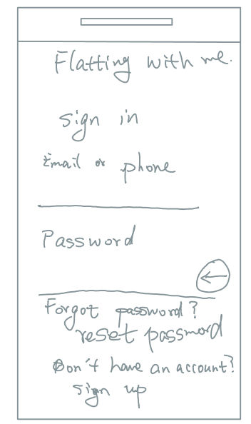

The sketch above is sign in page, which is very similar to all other mobile application or any other web application. Therefore, we conclude that it is no necessary to have any alternative for this page.

Rationale: The reason of using of common design it is because the layout is simple for user to understand. And the reason that skip mechanism is not designed is because user cannot join the group anonymously for security reason.

Pros: Very conmen design all user need is shown on the page such like reset the password and sign up option, besides input of user name and password.

Cons: No guest login option, so that user cannot view contain of the application.

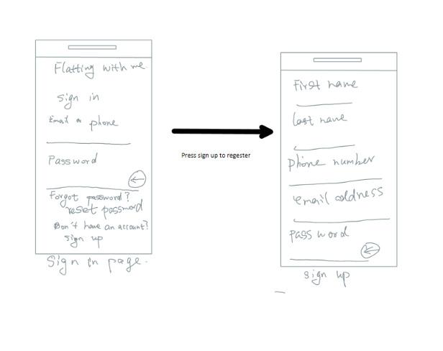 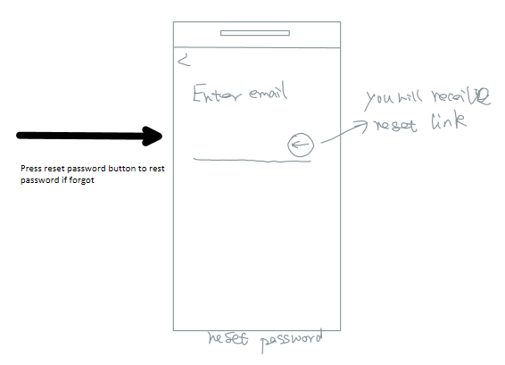

The sign up page and password reset page is the same as common app as no need to be changed. It come with the same pros of sign up page.

**Alternative one**

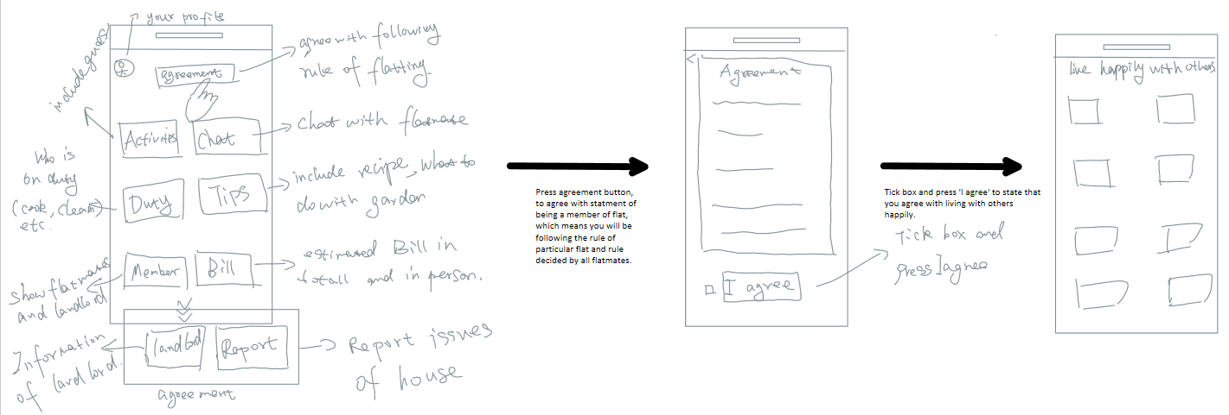

After signing in, the app will switch to home page, the home page is shown above, all contain relative to user tasks are designed into button which is very easy for user to find what user wanted to do. The whole design focuses on simplicity.

Pros: user will be able to operate the app without any guide, no need to familiar with UI. All functionalities are shown on home page as buttons, reduces times that user need to operate on app.

Cons: there will be no information shown whenever user opens the app. It would not be convenient if user just want to check schedule for duty or upcoming events.

The agreement is to let flatmates agree with each other that they need to follow the rule of flatting together and try best to lead a harmonious life. In this way, flatmates will keep the agreement in their mind whenever confliction comes. This may make difference during quarrel.

Pros: this remind users that they should take responsibility to their behaviours flatting with others.

Cons: When user not agree with agreement and it will be shown in user’s profile page, it may lead more confliction.

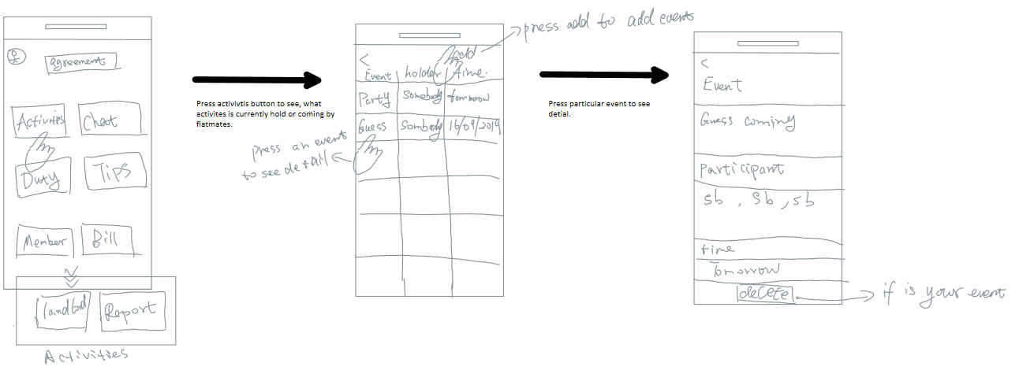

By pressing the activities button will switch to activities page, it shows all the event and details including yours. In this way, users could have a view of all upcoming event hold by their flatmates, user can edit all of it in order to adjust multiple events happen in the same time.

Pros: users always have view on whole schedule of the events that will happen in house, and prepare it. And can easily edit all of it to manage flat events

Cons: someone may be maliciously edit all of the events and makes everybody feel annoying.

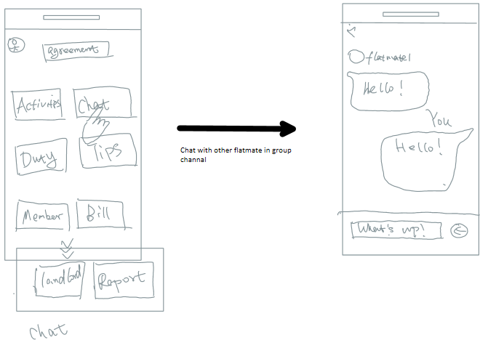

Chat functionality can give flatmates chance to communicate with each other without having their actual contact number. Like all kinds of chat app you tap sentence in to chat room and all of the flatmates will receive your messages. The chatting room not letting users to choose particular flatmate to talk because the main use case is for users to coordinate with all of flatmates rather than just perform as a chatting app.

Pros: Easy to use, everybody can see one’s message and response to it.

Cons: users would not find private chat in this block which may lead to confusing.

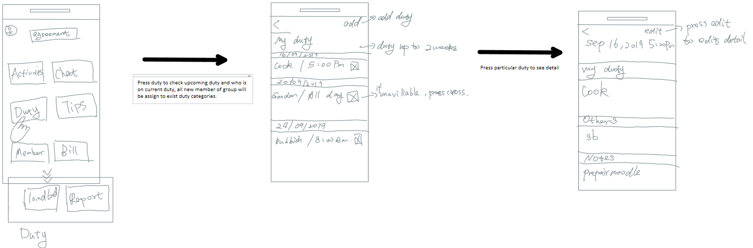

The flatmates will be assign duty automatically according to exists duty and its period. This will simplify the process of coordinate and avoid conflict between flatmates. It helps to ease running flat.

Pros: simplify the way to coordinate duty for flatmates, and itself will remind users when to do the duty.

Cons: may be assign the users to unavailable time.

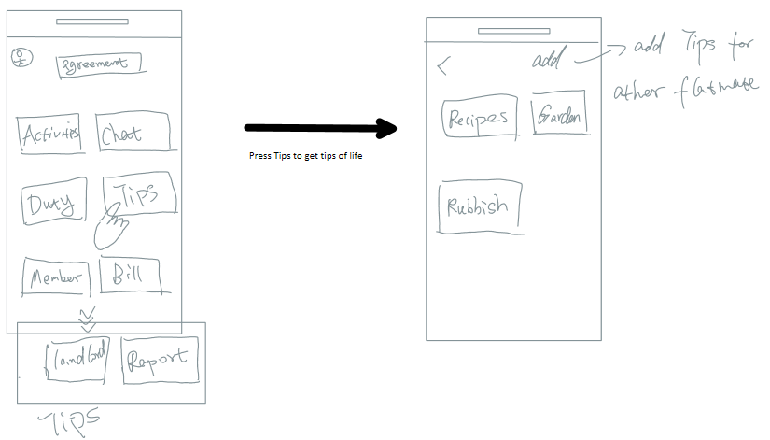

Tips gives users helpful information about what to do when they meet problem with doing duty and more tips can be added as notes. Same UI has been used compare to home page. This is a simple way that user can view all categories of tips at one look.

Pros: simple UI for user and provide easy and obvious visual to get what information that user want.

Cons: When tips gradually accumulate, users may hard to find wanted categories by scrolling down the UI.

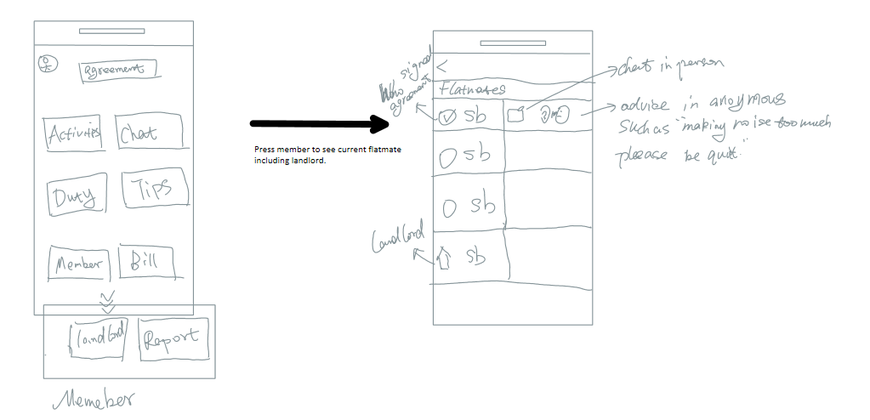

The member list of flat shows list of flatmates including landlord so that users can get in touch with landlord with app. And anonymous message button and private button are provided after each member icon. This gives user opportunity to chat in person instead of public channel, but reason putting it in there not in chat button it is because it may lead flatmates only share information to particular person not all flatmates.

Pros: by sending messages to person without having name tag on it, avoids confliction that directly talk with him brings.

Cons: it should belong to chat but not in chat could make user feel confuse.

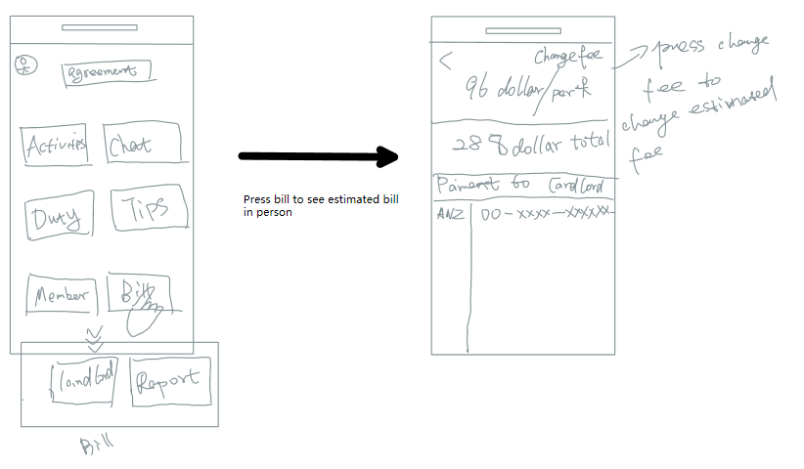

Bills helps users manage their rent and electricity and provides information of payment. Therefore, when users view this page, they would know their estimated or event accurate fee to pay if they up load data correctly. And do the bank transfer without checking anything else.

Pros: provides information about everything users need for paying the rent.

Cons: cannot pay the bill in the app, as landlords may require very different payment method for flatmates.

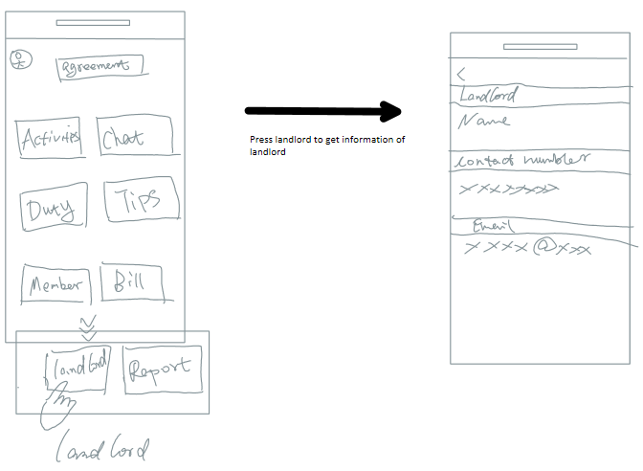

Information of landlord provided uploaded by landlord. There is not much thing can be shown in this page, necessary information is enough and further information could cause unexpected problem for landlord.

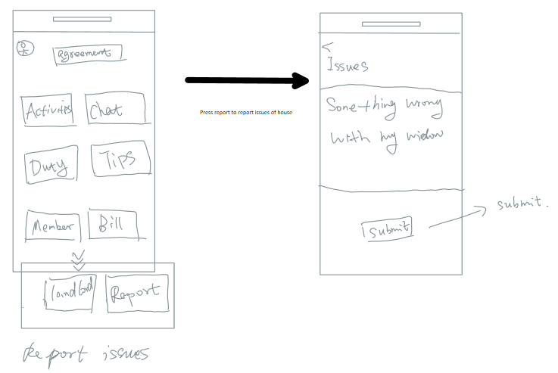

Report issues to landlord, without set up chat, makes it more like email not chat. As landlord could not reply issues anytime, multiple chat from different users could be annoying.

Pros: provides a very simple way to report situation of the house.

Cons: spamming submit from users.

**Alternative two**

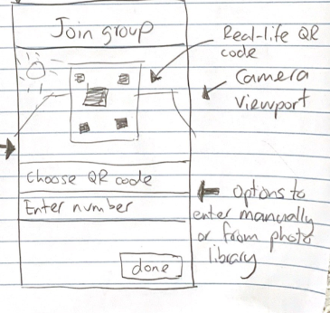

After signing up or login, if user not belong to any flatting group. A join group page will show up. QR code provides users a fast way to join the group by scanning the QR face to face. Number of the group also can be used as optional.

Pros: multiple way to join the group which is convenient.

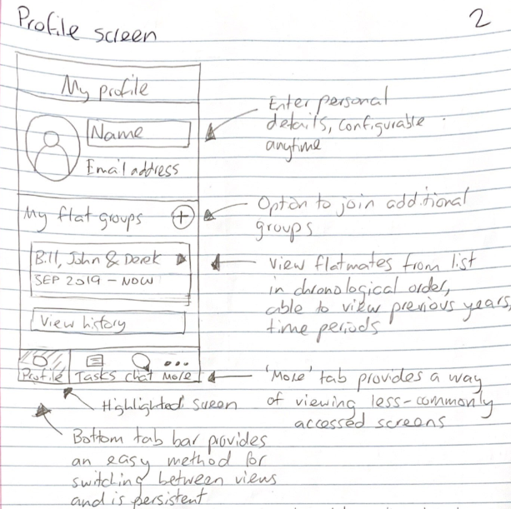

Profile is shown all the time in home page, so that detail of user can be change anytime. It emphasise the importance of personal profile helps flatmates know each other. Additional groups handle special situations. Flatmates detail can be view all the time on the home page, helps know your flatmates deeper. Your profile and flatmates profile always shown on home page means this app focuses on share personal information in order to improve relationship between flatmates. Task bar provides very handy way to access all the functionality of the app at any time.

Pros: users can easily familiar with their flatmates without talking face to face, just have a view of their profile. Quick access other functionality

Cons: chatting may be the better way to know each other instead of view the profile. Have no detail of upcoming event when user opens the app which leads to additional operate to the app.

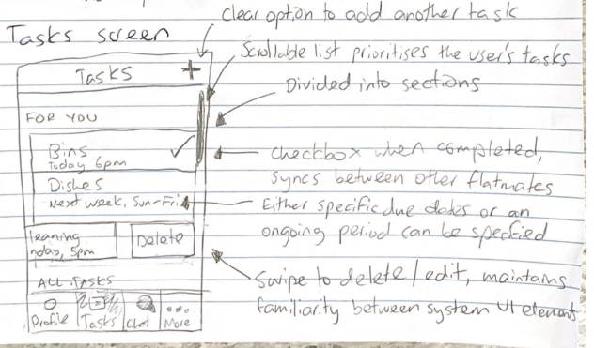

Compatible with iphone as it uses same mechanism to delete tasks. In this page, all information is about current and upcoming tasks. Therefore, users can easily find information they want for tasks.

Check box provided for users so that users know what have been done what haven’t been done.

Pros: any operation for tasks can be done in single tap or swipe. Iphone users would happy with this kind of operation. All tasks can be accessed in one page by scroll bar.

Cons: not be able to view others tasks for coordination.

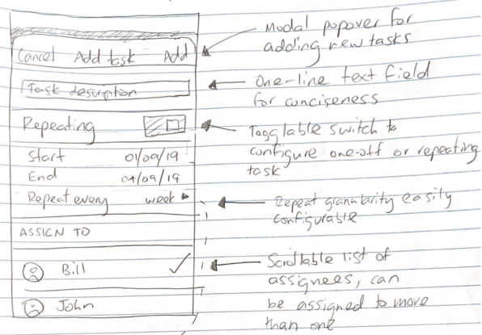 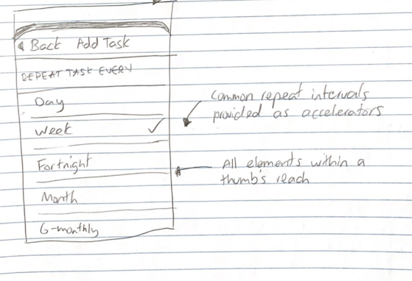

Task can be accurately set with time and be repeated each selected period. Assign to others provides method to manage duty for others, in this way, coordination problem has been solved.

Pros: if one of the flatmates is managing all the duties for others, it provides easiest way to coordinate all people by providing mechanism for user to be able to assign duty to other flatmates.

Cons: if no one been decided to be managing flat activities then assign to other people could cause flatmates been assigned task without agreement.

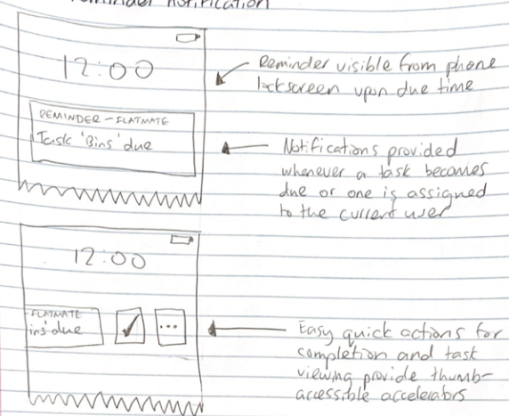

Reminder for outside app use case. User don’t need to open the app, this is a common mechanism in all other apps, and short cut for check box make it is possible to do something without opening the app.

Pros: as all other app it is useful Characteristics like a reminder.

Cons: could be annoying when too much duty or tasks been assigned in short term.

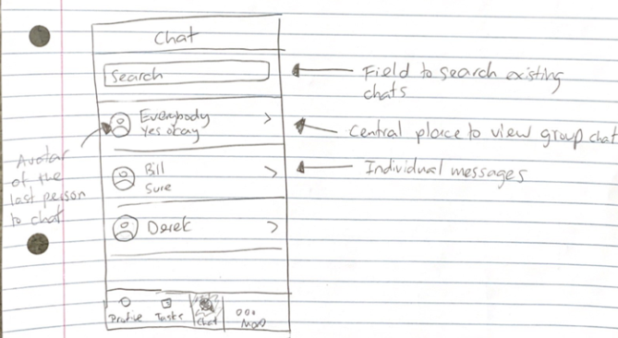

Putting all history of chat together, so that it is easy to find previous chat. Also provide public channel for announce anything important for all flatmates it makes.

Pros: clear way to show all chat and fast to start a chat with group member.

Cons: search function could be not useful as there would not be much people in flat.

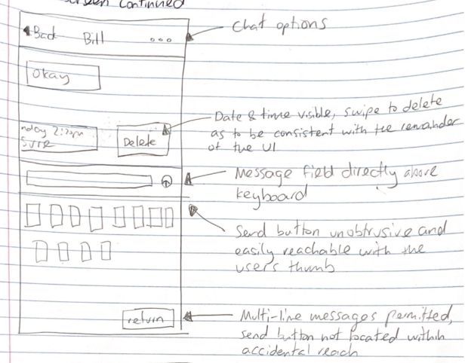 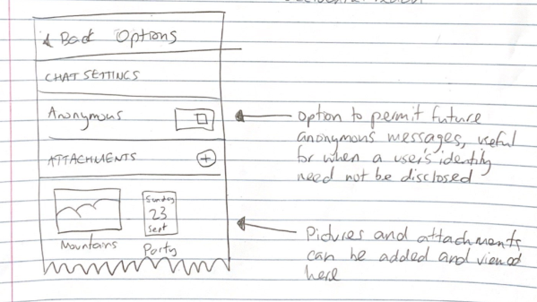

Like common chat app, similar funcionality but with anonymous mode in order to avoid inconvinient situation. Time and date of last message is provaded in order to remind user when chat happened last time. Message can be deleted for some purpose.

Pros: easy to be used and help coordinate events for flatmates. Anonymous mode provieded for situation that users do not want to be identify.

Cons: anonymous mode may also leads to misunderstanding.

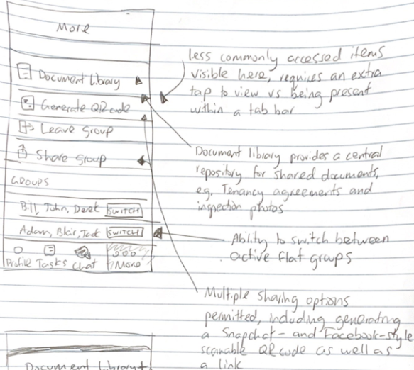 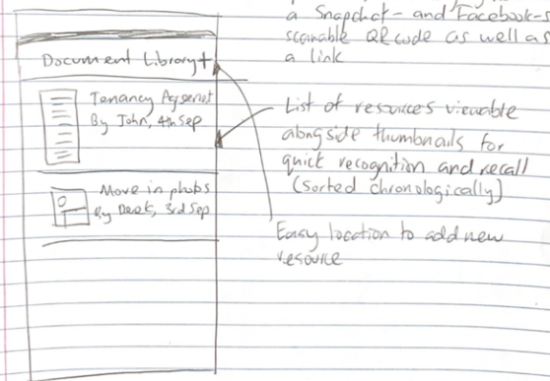

Less commonly used items are put together so that no more UI need to be design as too many UI makes user feel hard to find the page that they want. Document library is provided for storing some useful information such as payment account or sharing moment to all other flatmates.

Pros: gathering all less commonly used feature together reduces times of user operation.

Cons: could be messy to find desired items.

**Primary Preliminary Design**

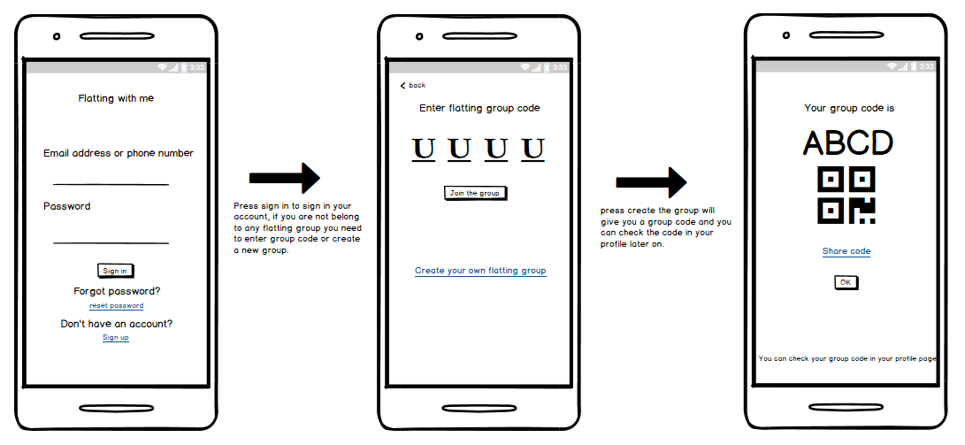**Sign in page**

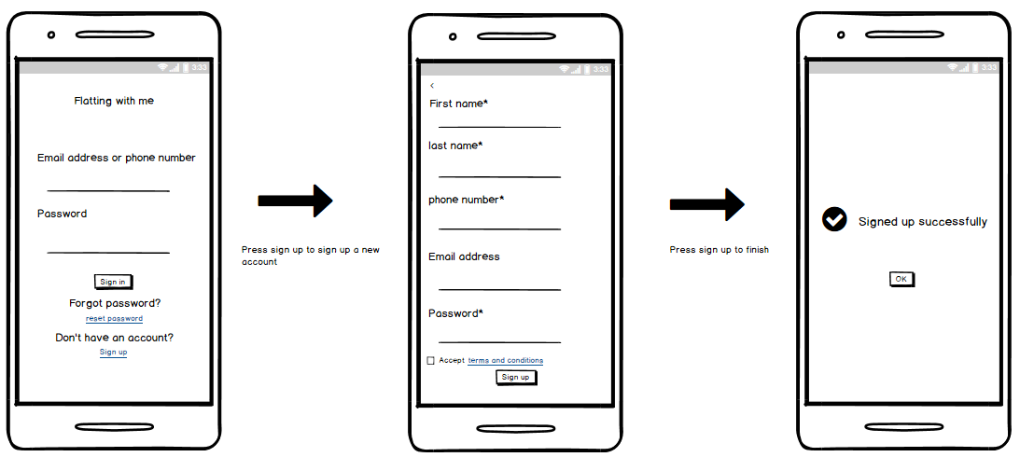

**Side menu**

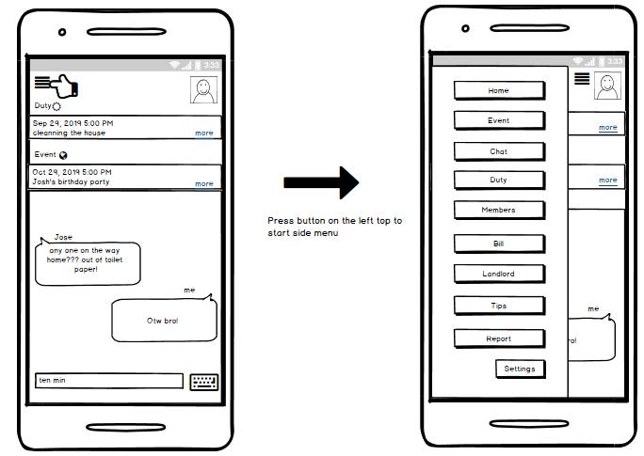

**Profile**

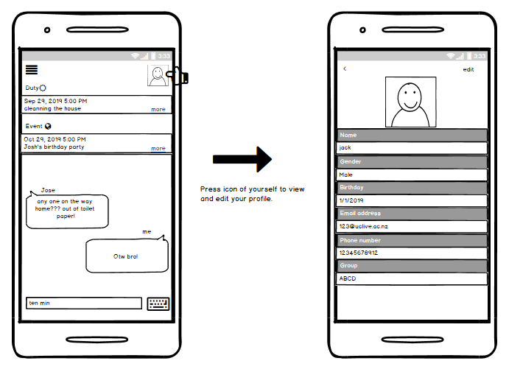

**Events**

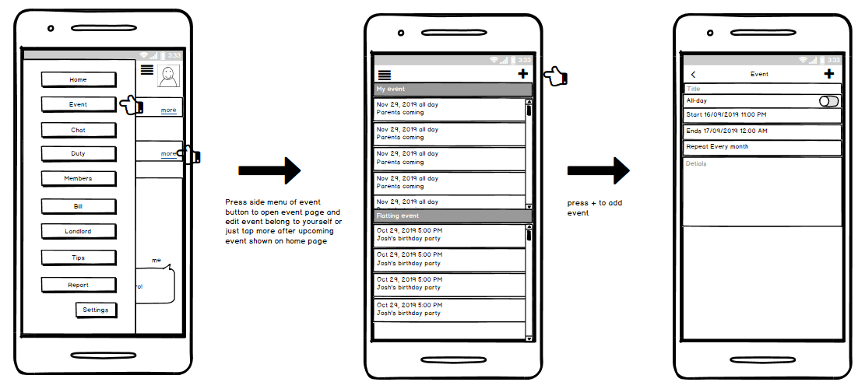

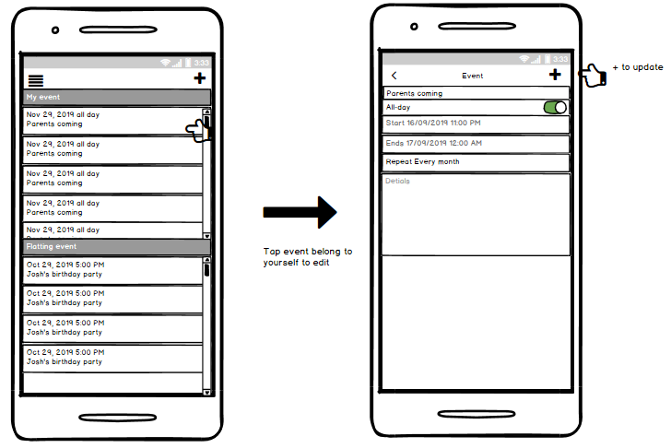

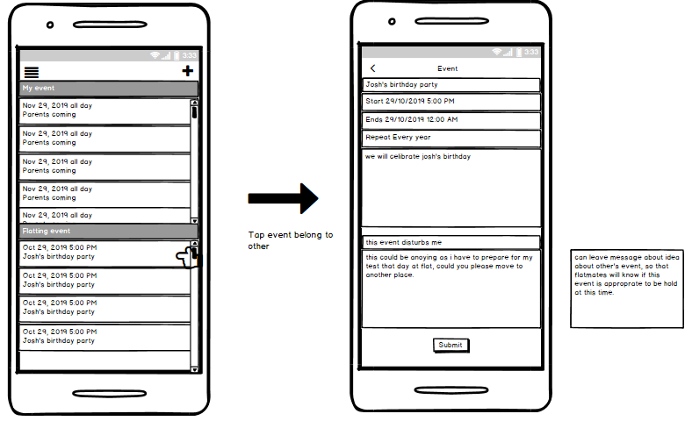

**Chat**

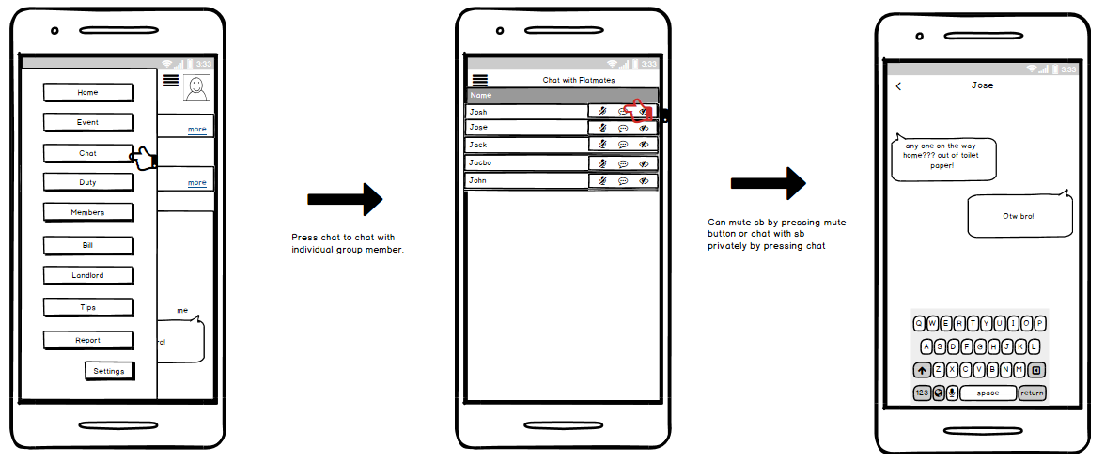

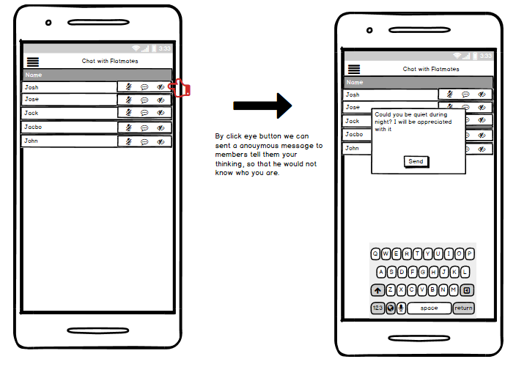

**Duty**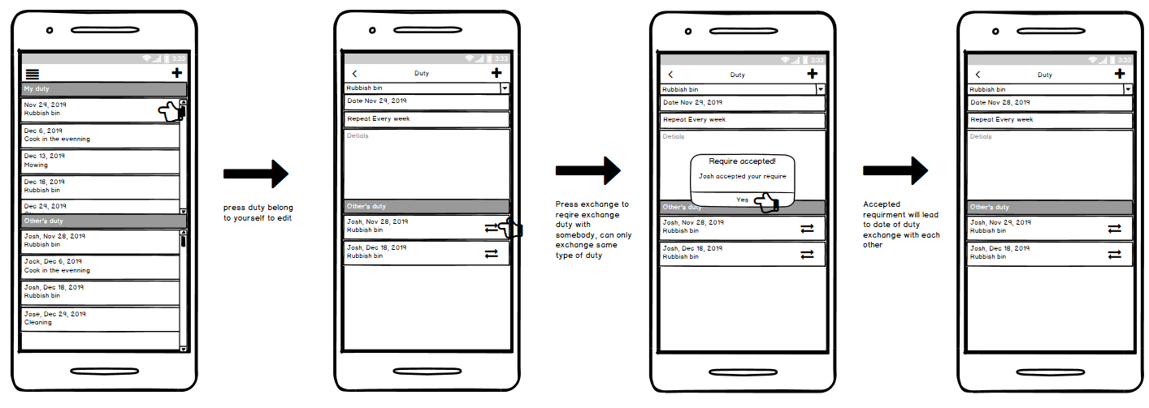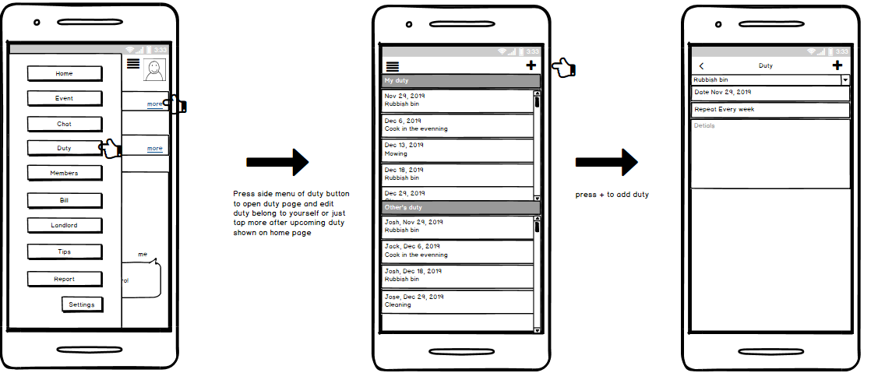

**Members**

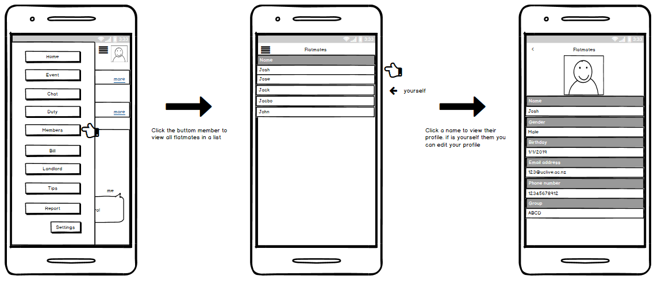

**Bill**

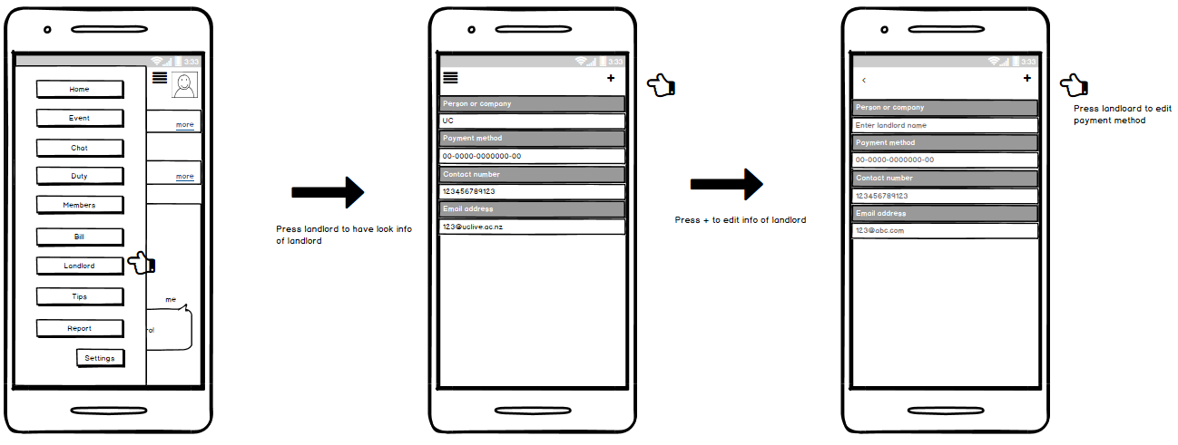 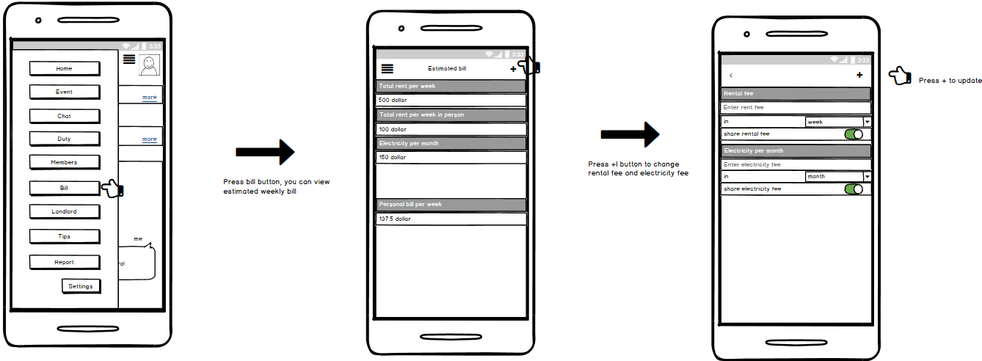**Landlord**

**Tips**

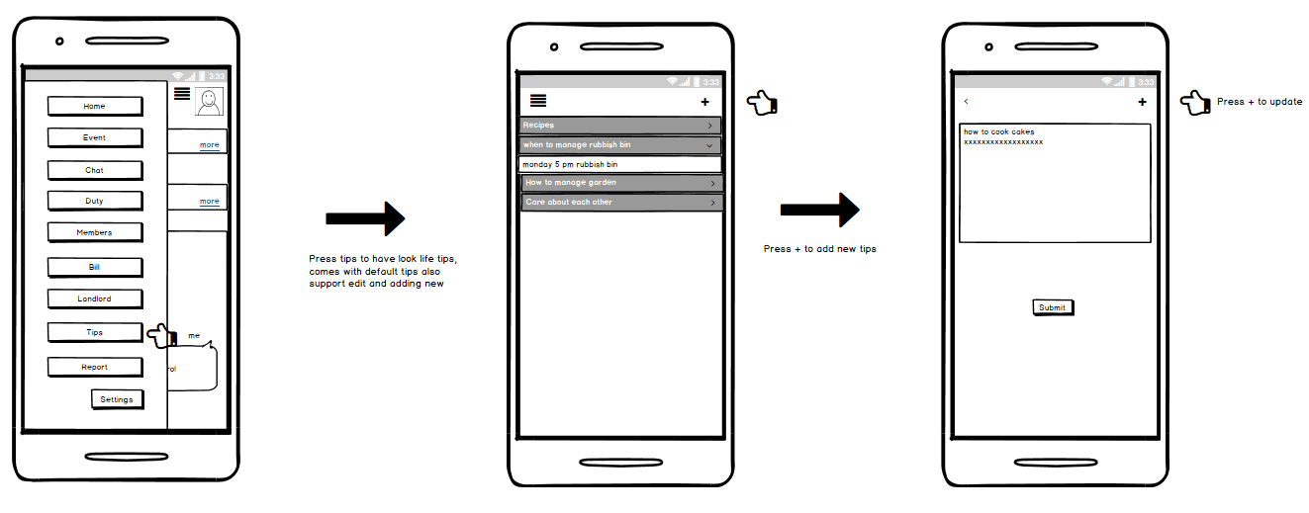

**Report**

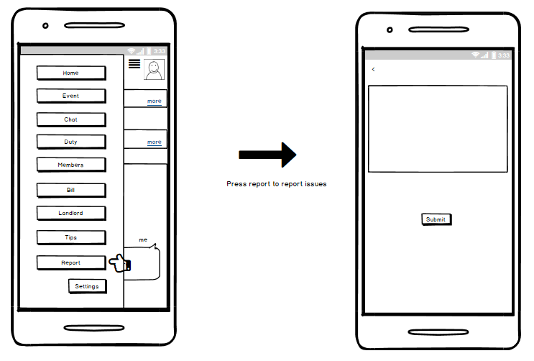

**Settings**

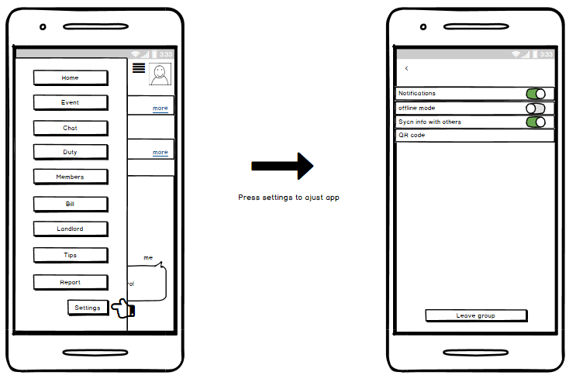

The primary preliminary design has been decided as combination of two alternatives of preliminary design with small amount of new changes.

Sign in page uses second alternative provides QR code and group code which provides fast way to establish flatting group. It would be fast in either face to face or remote adding. This avoid adding group members one by one.

As the weakness been analysed for home page of two sets of alternative designs, is that whenever user opens the app it is not showing any useful information for reminding user what to do for flat. And user have to tap duty or task to check what upcoming task is. In fact, checking upcoming flat event and task is the most frequently used functionality for users. The primary design solved this problem by simply putting upcoming event and duty onto home page, so that user can easily access these information by opening app. This is the best solution.

Two alternatives all provide public chat, to make most common used functionality even easier to be used, is that put public chat below the upcoming events. Therefore, two commonly used tasks can be directly used. Otherwise, keep talking with all of flatmates improves relationship and coordinates events. This is the aim of the app.

Side menu instead of bottom menu has been used as it avoid unexpected operation. Side menu can be accessed anywhere in the app. Therefore, it reduces operation to switch back to previous page. This could be the best way to manage the whole app.

Both alternatives cannot show other’s duty, it is been solved by divide the page into two block one for user’s, one for other flatmates. In this way, user is able to have a view of other flatmates’ duty and ask for swapping if user unavailable with his\hers. Automatically assign for duty was kept from alternative one for convenient purpose. With swapping functionality, this mechanism becomes easier than before. This is the best combination so far.

Public chat has been moved to home page, therefore, chat button leads to private chat room which reduces confusing. Anonymous message is provided instead of anonymous chat as chat in anonymous is easy to be identify who it is. A pop up message is more acceptable and leads to less conflict.

The events page is also been divided into user’s and flatmates’. And suggestion or disagreement can be sent to event holder for coordinating flatting activities. This helps to coordinate different events from different people and avoid inconvenient.

Tips page is now shown in different way in order to display more tips at the same time.

This primary preliminary design improves all weaknesses of alternative designs and combines their advantages. Therefore, this design is the preferred initial design.

**Conclusion**

By analysing possible user tasks and presentative users, main tasks that user can perform using app was decided. Chat is the main way to coordinate activities and improve relationship between flatmates and leads harmonious flatting life. Most of the conflicts are caused by lack of communication. Therefore, public chat is designed to be shown on home page as main user task. The other main task of user is coordinating events and duty. Remind of duty and events are also designed to be shown on home page. Despite two main tasks, several useful utilities are also designed for user to improve user experiment.

The best concept of two alternatives are combined together for final design, and shorts are avoided in order to get preferred final design. Therefore, the primary preliminary design is the preferred design and satisfy the requirement for company FlatMate Ltd.

**Contributions**

Enyang Zhang: alternative design, report writing, design refinement

Hui Zhuo: alternative design, design refinement

Jack Greenhill: alternative design, requirement analysing

Bryan Lim: report correcting, design refinement